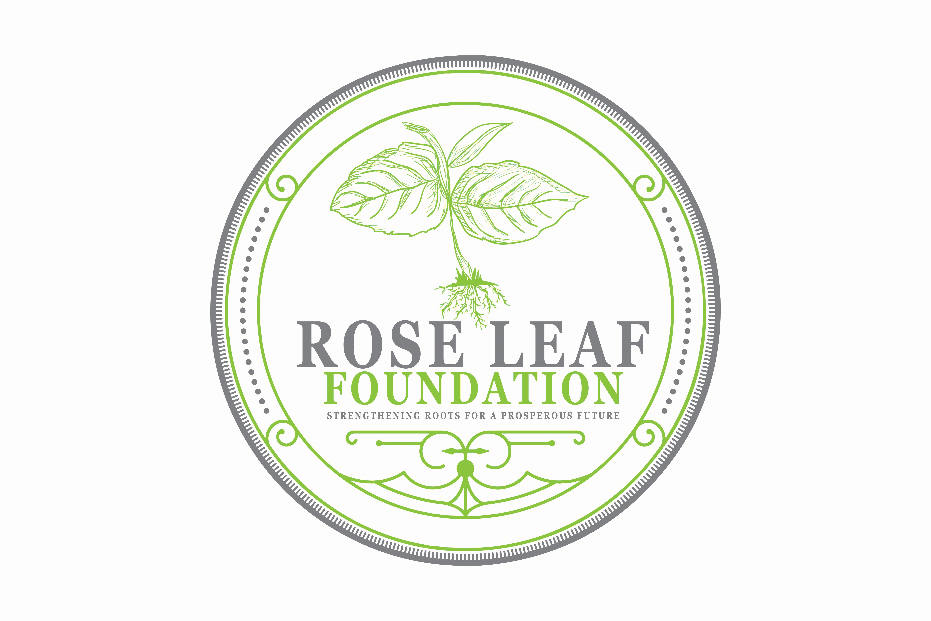

Contact Information:
Rose Leaf Foundation
Mrs. Faith Davis, Founder
(803)386-8279
info@roseleaffoundation.org
Release Date: March 7, 2022

FOR IMMEDIATE RELEASE
Rose Leaf Foundation and ConverSpace Presents a Children’s Book Drive

March is National Reading Month and Rose Leaf Foundation is celebrating by partnering with The ConverSpace to host a book drive. Please help to spread the gift of literacy to children and teens in foster care.
Rose Leaf Foundation is working to help children in the foster care system and young adult who have aged out of foster care to thrive beyond boundaries. We know that sometimes all it takes for is a little support for them to succeed. Since 2019, we have been determined to make an impact in the lives of those we serve. Through all of our endeavors we hope to display the conviction behind our beliefs.
We realize that there are many benefits to reading such as improving vocabulary, better comprehension, developing critical thinking skills, improving memory, and increasing focus and concentration. Please help us to provide an opportunity for a child to experience these benefits by donating a new or gently used book. Books can be dropped off by March 25th at The ConverSpace at 136 Forum Dr., Columbia, SC 29229 or mailed to Rose Leaf Foundation at P.O Box 29303 Columbia, SC 29229. You may also visit our website at: www.roseleaffoundation.org to find out more ways you can donate or volunteer.
###

